Data validation
Previously, we already considered the possibility of checking the filling of attributes and tabular parts by setting the value "Display error" of their "Required field" property.
But there are more complex checks when it is not enough to check that the attribute is filled in; you also need to check that the correct data is entered. For example, when selling goods and services if it is indicated that the sale is subject to VAT, you need to control the filling in of the VAT rate for each product and service in this document, otherwise it can be left blank.
Another example: there is a Sales order document. It has a field “Shipment date”, which is required to be filled out. But it is not enough to fill it with any date; the date of shipment must be no earlier than the date of the document, because an order is only an intention to purchase goods from us, the goods cannot be shipped before the order itself has arisen.
When implementing a check for the correctness of filling out an object, first of all, it is necessary to determine in what cases the check should be performed: for example, for a document it can be the moment of any writing, the moment of posting the document, the moment of recording/posting, but only interactively (from the form). Often, for documents, checks are performed at the time the document is posted, since this is a recording of the operation; an unposted document is like a draft.
If the check must be performed when writing a document, regardless of whether it is interactive or not, then the check is described in the FillCheckProcessing object event:
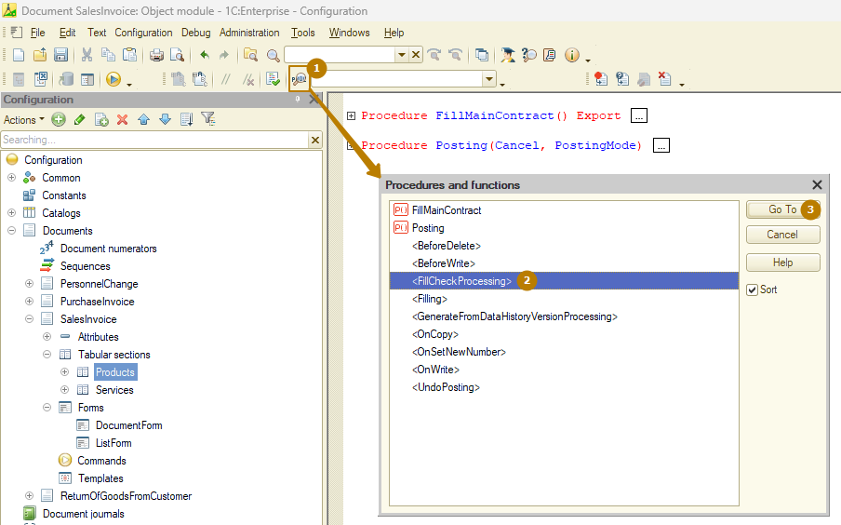
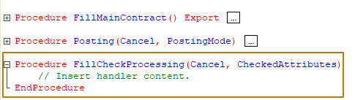
This event occurs in two cases:
- during interactive work (interactive work - working directly with objects from the interface, for example, selecting a document in the list form and pressing the Post button). For a document with the posting mode enabled (standard mode for a document) during interactive posting, for other objects that have this event - during interactive writing.
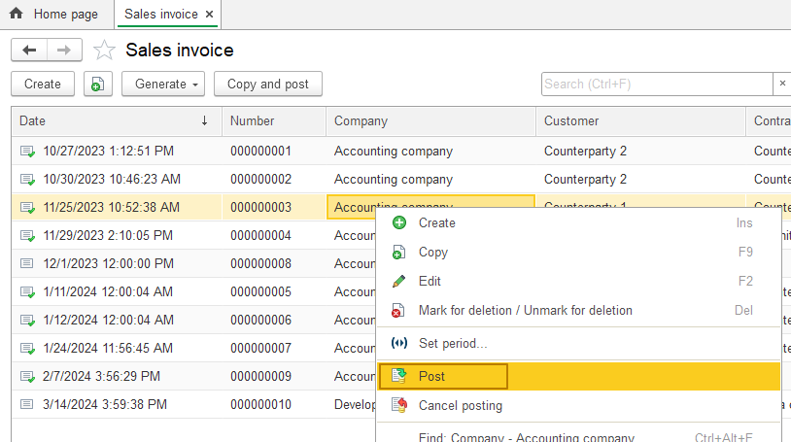
- during work from code. Calling the object's CheckFilling() method triggers the FillCheckProcessing event. Without calling this method, even posting a document from code will not cause this event to occur.
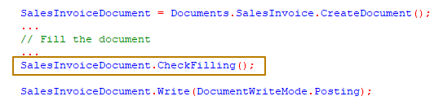
Let's take a closer look at the FillCheckProcessing event. The procedure has two parameters: Cancel and CheckedAttributes. Cancel has a default value of False; if this value is changed to True, the posting (writing for objects without posting) will not be performed and the user will see a system window with a message about the failure of the operation:
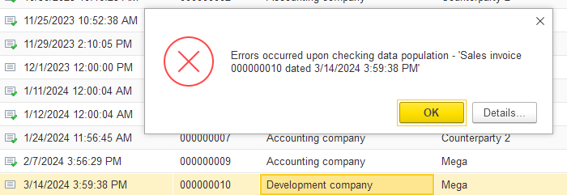
The CheckedAttributes parameter contains the names of attributes and tabular sections, the filling of which will be checked upon exit from this procedure:
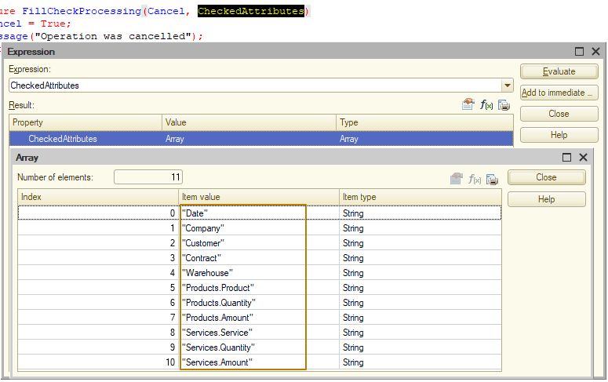
Typically, conditional filling checking is implemented in this way: the "Required field" property of an attribute/tabular section is set to the value "Display error", and the event handler specifies the conditions when it is necessary to remove this attribute/tabular section from the list of checked ones.
Let's look at an example: the Sales Invoice document has 2 tabular sections: goods and services. We want that when posting a document, a check is made that the document contains at least one row of any tabular section (products or services). To do this, I make it mandatory to fill them out in the properties of the tabular parts
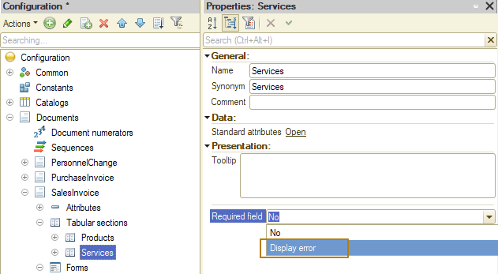
and then in the FillCheckProcessing procedure I add an algorithm that excludes the Services tabular part from the check if there is at least one row in the Products tabular part and the opposite condition
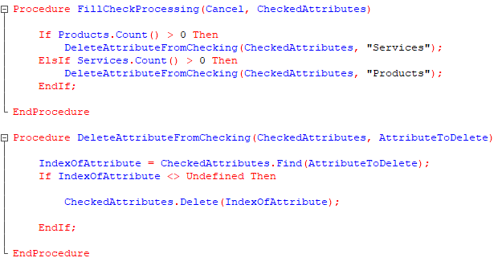
Note that elements from an array should be removed by their index. The index of an element can be obtained by the Find() method, which returns Undefined if the required element is not found in the array.
Since the code for finding an element and removing it from the array is repeated for two conditions, I moved it into a separate procedure.
We check in enterprise mode: if there are no rows in any of the tables, the platform shows the message that there are no rows in each of them.
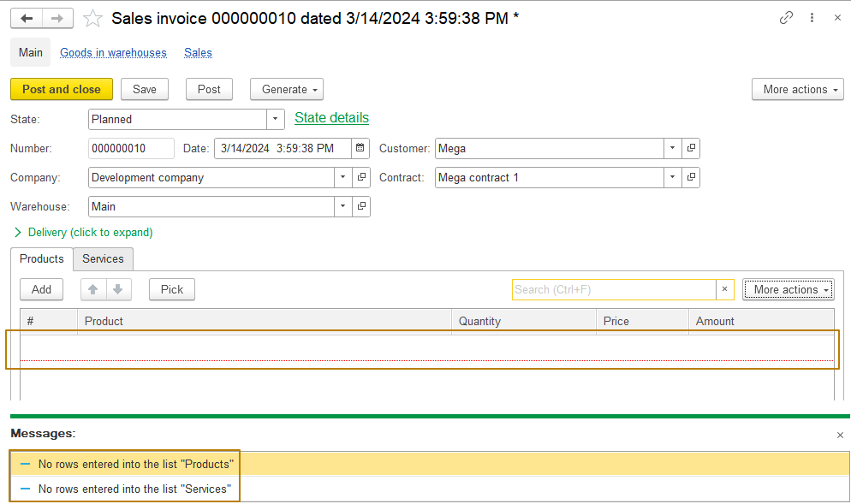
If the row is in at least one table, there are no errors.
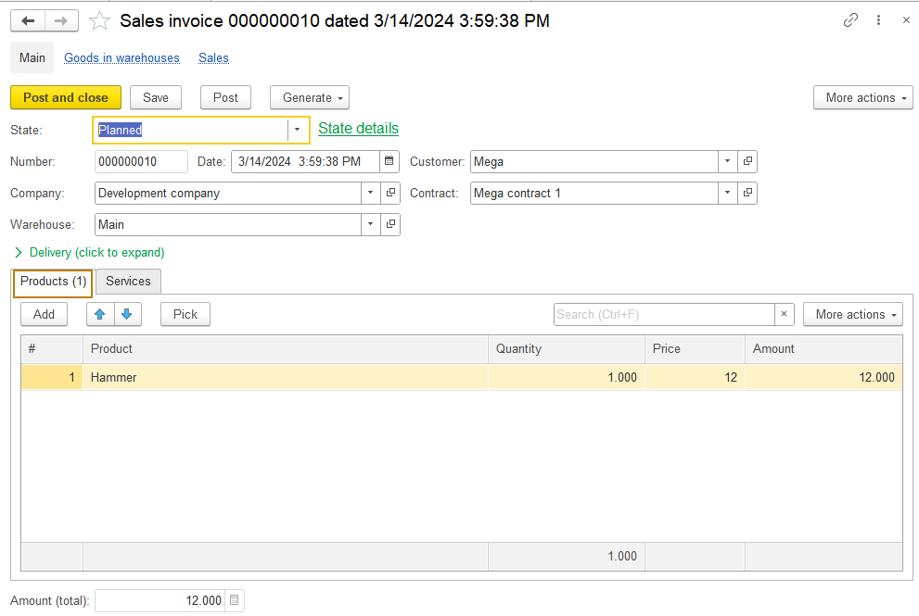
Let's move on to a more complex check. I want to show a situation where it is required to fill in some column in one row of the tabular section, but it is not necessary to fill the same column in another row of the same tabular section. Now in my configuration it is necessary to fill in the Amount column of the Products tabular section of the Sales Invoice document . Let’s imagine that there is a need to distribute promotional products to clients, which are recorded in the program, but at a zero price. In order to implement such an algorithm, I will add the “Promotional” attribute to the Products catalog.
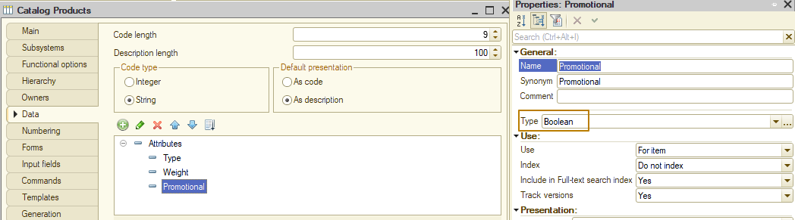
Moreover, such an attribute should not be available for the service. Currently, the Products catalog already has a "Weight" attribute, which makes no sense for services. Let's implement disabling the visibility of "Weight" and "Promotional" if the product is of the Service type. I add a group to the form and move the necessary elements into it.
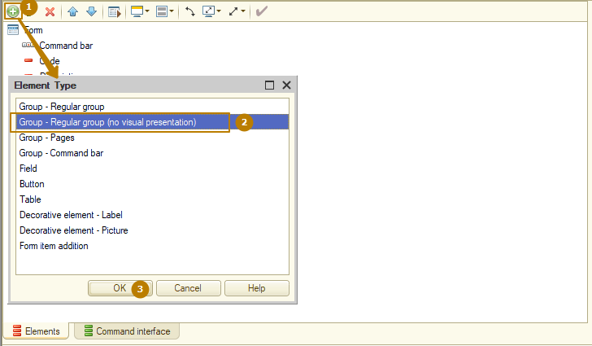
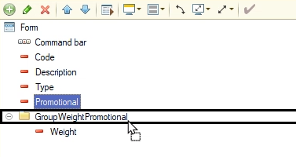

Now the 2 elements are positioned horizontally one after the other:
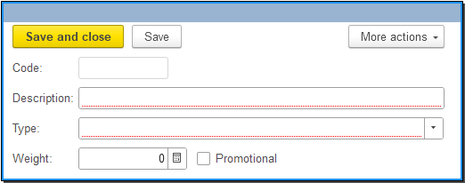
I’m adding an OnChange event handler for the Type field so that when the type changes, the visibility of the form fields is updated.
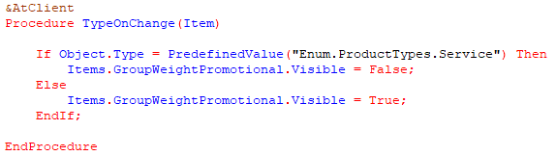
However, there is a problem - the visibility is updated only when there is a change in the Type field, and when opened, the visibility will be the default one, and if you open a catalog form with the Service type, unnecessary fields will be visible.
In order to change this, I need to call a visibility update from one of the events that occurs when the form is opened. Since I'm managing visibility on the client, I'll use the OnOpen client event. Form events can be added both from the form properties palette and from the list of procedures and functions in the form module:
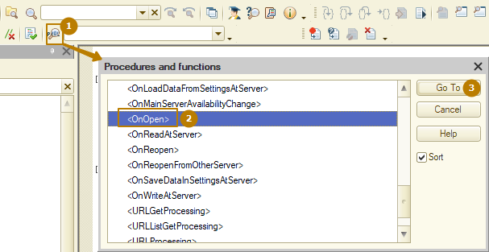
And so that I don’t have the same code in two different places, I create a separate procedure that I call from event handlers.
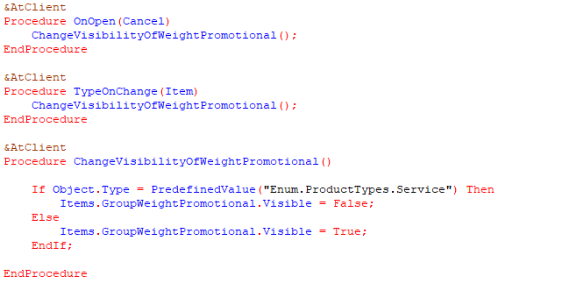
Result for product shapes with different types:
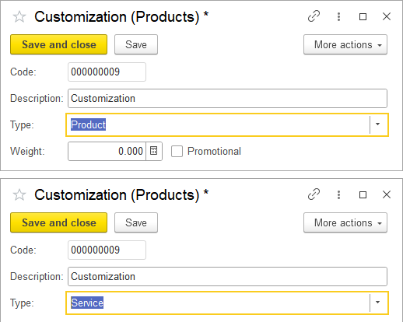
Next, I add an algorithm for checking zero amounts to the Sales Invoice document. The optimal way is to use a query to select those document rows of the Products table with an empty amount in which the product has a product type and it is not the “Promotional” (Promotional = False).
A very important detail should be taken into account here: the FillCheckProcessing event is executed before the object is written to the database, which means we cannot select data from the object by reference, we must work with the object data that is available to us.
But how to work with the current data of an object whose changes have not yet been recorded in a query? We can pass tabular section data into a query, but to do this, we must select it into a temporary table, and after that we can work with this temporary table in subsequent queries:
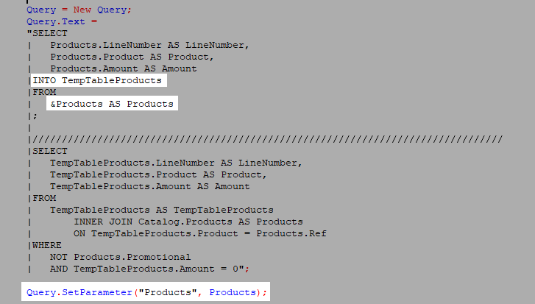

Full code for our own check:
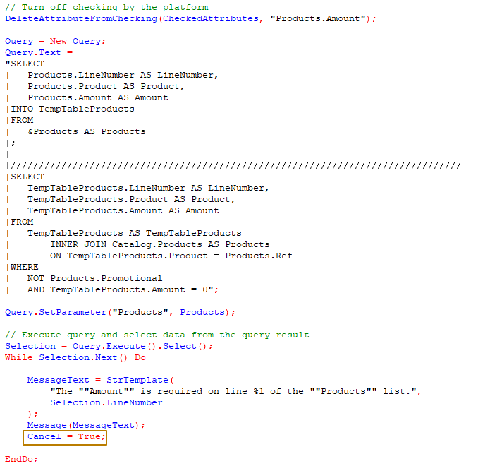
In order to cancel the write/post operation, I change the value of the Cancel parameter to True, and also inform the user about the error.

Let's check if our algorithm works correctly. I add a regular product to the Products tabular section, then a promotional product and another regular product and try to post the document. As you can see, messages are displayed for lines 1 and 3, line 2 is skipped, which means the checking is correct:
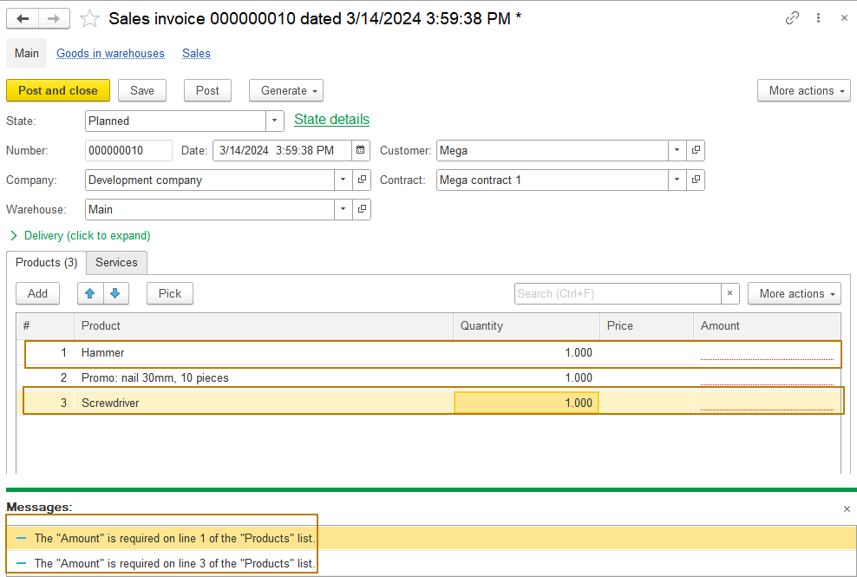

Information registers
The purpose of the information register is to store information necessary for various tasks. Unlike the accumulation register, in which resources are always numerical values, any information can be stored in the information register, for example, responsible persons of organizations, email settings, product prices, etc.
The structure of the information register is similar to the structure of the accumulation register - it consists of dimensions, resources and details. The difference is that in the information register, the platform controls the uniqueness of records based on a set of dimensions, so there cannot be two records with the same set of dimensions in the information register table.
Let’s take, for example, an information register for storing responsible persons in organizations. It has the next structure:
Dimensions: Organization
Resources: CEO, Chief Accountant, CTO.
I add a record to such a register, so it has the data from this table:
Organization | CEO | Chief Accountant | CTO
Best chocolate | John | Rose | Bob
Then, even if the resource values are changed, the platform will not allow you to add a second record for the Best chocolate organization; an exceptional error will be raised:
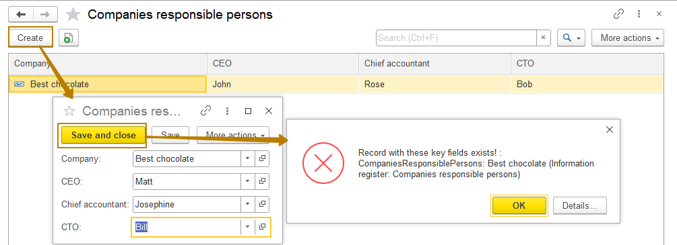
If we change the set of dimensions (in our case consisting only of the organization), then the record will be added:
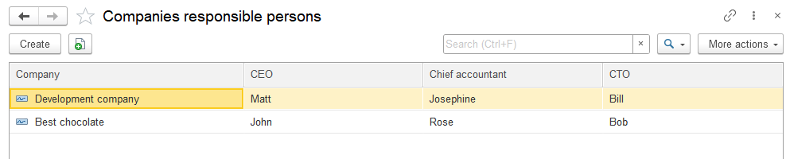
Periodic information registers
But what if we need to store not only current responsible persons, but also the history of past responsible and those who will become responsible in the future? For example, an employee wrote a letter of resignation and will stop working for the company from a certain date. Let's assume that we find a replacement for him and on the day the old employee leaves, a new one will take his place. We would like the system to automatically substitute a new person in charge instead of the old one starting from a certain point.
For this purpose, the information register has the “periodicity” attribute, which allows to store values in the context of a set of measurements and period. The periodicity has the following values: None, Second, Day, Month, Quarter, Year.
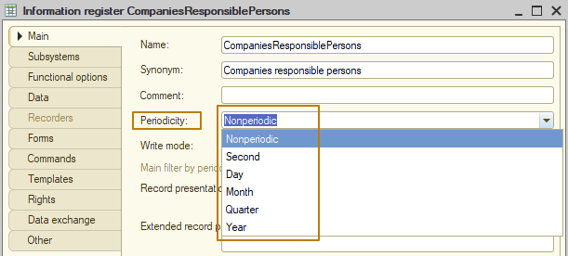
If I set the periodicity to “Day” for our information register, I can change resources for the same organization no more than once a day. In this case, the platform controls the uniqueness of records based on a set of dimensions + the Period service attribute, which is automatically added by the platform in the periodic information register.
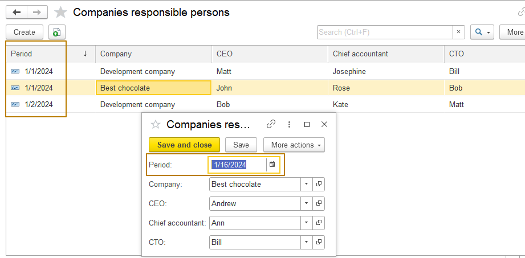
There is one more periodicity value that can be selected only from the periodic information register, which is subordinated to recorder - “By recorder position”:
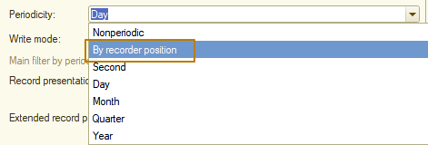
This periodicity allows you to have records with the same set of dimensions + period, subject to different recorders. In reality, such a case practically never occurs; most processes require uniqueness of records; for example, it is difficult to imagine a situation where you might need 2 identical records for prices of goods in one second of time.
Virtual tables of an information register
The information register, like the accumulation register, can have virtual tables, which obtain data from movement or totals table at the database level (it depends on a register settings).
First of all, it should be said that the information register has virtual tables only if it is periodic. There are 2 virtual tables: SliceFirst and SliceLast. Let's look at how virtual tables of the information register work. Suppose the register table currently contains the following data:
Period | Company | CEO | Chief accountant | CTO
1/1/2024 | Development company | Matt | Josephine | Bill
1/1/2024 | Best chocolate | John | Rose | Bob
1/15/2024 | Development company | Bob | Kate | Matt
1/15/2024 | Best chocolate | Andrew | Ann | Bill
1/22/2024 | Best chocolate | John | Rose | Bob
If you access the SliceLast virtual table and request resource values without selecting by dimensions (by company) for the date 1/25/2024, you will return 2 rows:
Period | Company | CEO | Chief accountant | CTO
1/15/2024 | Development company | Bob | Kate | Matt
1/22/2024 | Best chocolate | John | Rose | Bob
That is, such a table contains the latest data for the specified date. If you request the data again, but for 1/21/2024 11:59:59 PM, then for the Best chocolate organization it will return a record with a period of 1/15/2024, because it is the last one with that set of dimensions for 1/21/2024:
Period | Company | CEO | Chief accountant | CTO
1/15/2024 | Development company | Bob | Kate | Matt
1/15/2024 | Best chocolate | Andrew | Ann | Bill

Write mode of information registers
The next difference between the information register and the accumulation register is that entries in the information register can be changed directly, without a recorder document; such a register is called independent. This register behavior is controlled by the "Independent" value of the "Write mode" property (any information register when created has this value by default):
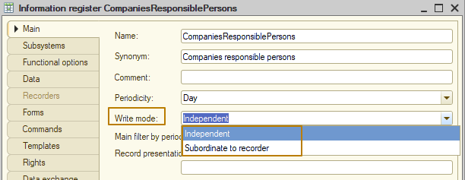
Independent registers are used when there is no connection to the company’s business processes or there is no need to restrict user access to the register directly (for example, it is better to change the prices of goods through a separate price setting document to avoid situations where a user can change register entries without leaving traces in the system), often these are service registers for different purposes, such as “Email settings”, “Exchange history”, “Financial accounting policy” and others.
As we remember, a document in 1C is a reflection of some kind of operation. If our company does not have the operation of setting responsible persons, then there is no point in creating such a document in the accounting system. Therefore, the “Companies responsible persons” register should be made independent.
Records to an independent register can be performed from code, just like for a subordinated to recorder register, the difference is that there is no need in a reference to the recorder to add such records. Let me create my own form that will make it more convenient to work with companies responsible persons register.
I created an item form for the Company catalog, then I added 3 attributes to the form with the CatalogRef.Users type: CEO, Chief accountant, CTO. Next, I created the “Responsible persons” group and moved the created attributes to it
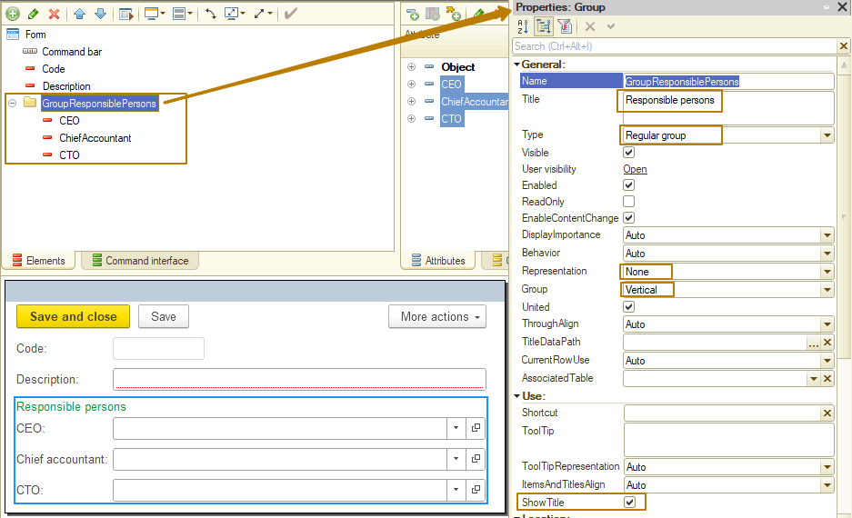
Now my task, when opening this form, is to read the responsible persons relevant for the current date. For this purpose, the periodic register has virtual tables SliceFirst and SliceLast, which return the latest values for each set of dimensions on a specified date.
Obtaining data from virtual tables of the information register is possible using a query to these tables
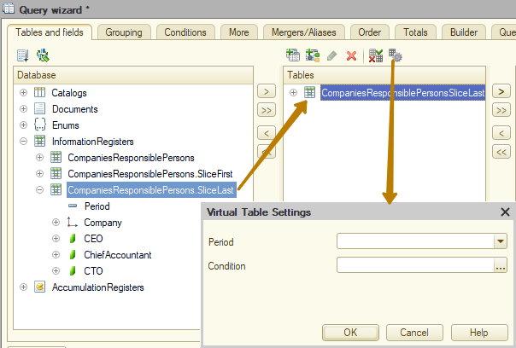

and using register methods, which in turn are divided into 2 types:
1) Complete analogue of the query. These are the methods SliceFirst(<BeginOfPeriod>, <Filter>) and SliceLast(<EndOfPeriod>, <Filter>)
2) Obtaining only the resource values of one set of dimensions. These are the GetFirst(<BeginOfPeriod>, <Filter>) and GetLast(<EndOfPeriod>, <Filter>) methods
Methods of the first type return a table of values, which may not have data if there is no data corresponding to the selection in the register table.
Methods of the second type return a structure in which the set of properties matches the register resources. Moreover, if there are no records in the register table that correspond to the selection, the values in the structure will have default values for the corresponding types of resources.
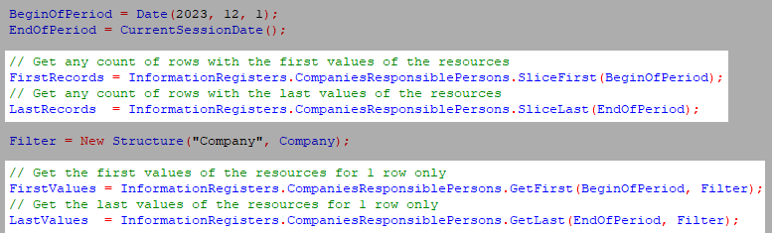
In our case, the task is to get the value for one set of dimensions, which means you I use the GetLast method and get data for the current date and the current company (the form of which opens). Data can only be read on the server, so I created a handler for the server event that occurs when the form is opened - OnCreateAtServer.
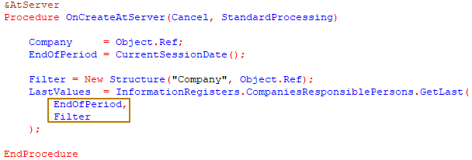
Next, I need to fill the form attributes CEO, ChiefAccountant and CTO with the received data. To do this, I can use the global method FillPropertyValues(), the first two parameters of which are Receiver and Source. Values that match the names in the receiver and source will be filled in in the Receiver:
FillPropertyValues(ThisObject, LastValues);
Let’s check the result. I open a company form for which there are no records in the register
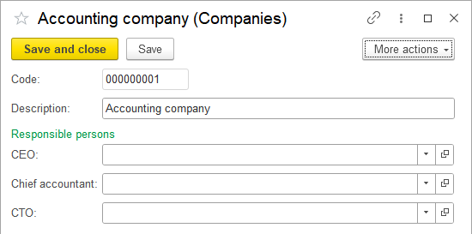
and then a company form for which there are several records and check that the form is filled in with the correct data
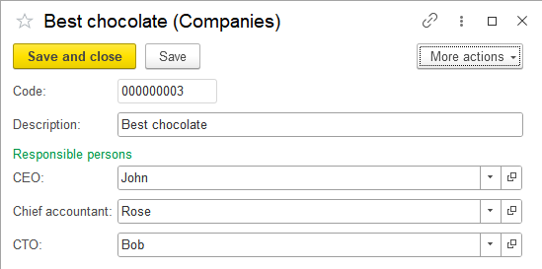
The data is correct - for the Best chocolate company, the responsible persons are filled in according to the latest register record as of the current date.
The first part of the task is completed. Now it is necessary to implement the recording of the data entered in this form into the information register when recording a company element. The algorithm should be as follows: first of all, you need to get the last record for the current date again. Then compare the resource values from the register with the values of the form attributes. If the value of at least one resource is different, I should add a record to the register with the values from the form and the current date.
Therefore, I should write a code with an algorithm for writing data to the register in the AfterWriteAtServer form event handler, when the object has already been written to the database and the transaction is committed (I will tell you more about what transactions are and what events are performed before/inside/after the write transaction a little later).
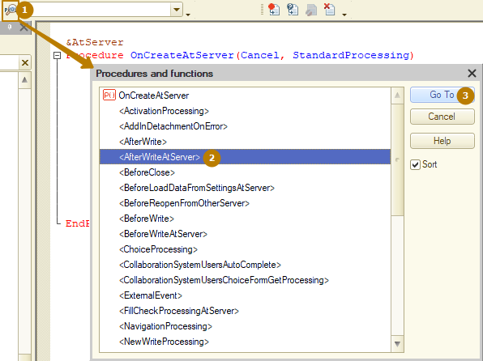
Since getting the last record data here is the same as what I wrote in the OnCreateAtServer event, the code can be put into a separate function and called without duplicating the code
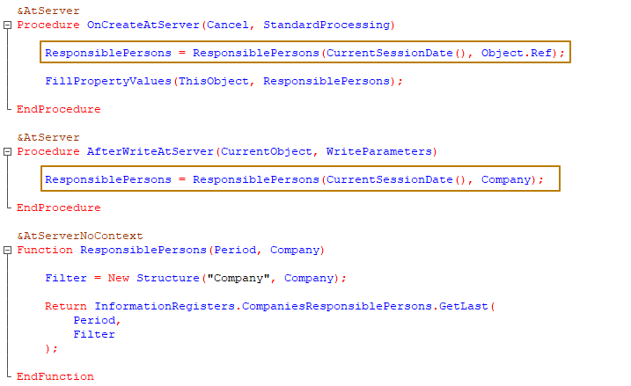
There are two ways to add records to an independent information register - using the RecordSet and RecordManager tools.
RecordSet is a universal tool for working with register records; it allows you to read, write and delete entries. In fact, when we were working with accumulation register movements from a document, we were also working with a RecordSet, we just didn't need to create a new set, we got it from the RegisterRecords property of the document object.
RecordManager is an add-on to RecordSet, made simply for convenient work with ONE record of the information register. RecordManager can only be used for independent information registers.
Note: since RecordManager is designed in such a way that at the system level it uses two RecordSets, one for deleting an old record and the second for adding a new one, it is not recommended to use this tool if it is known in advance that a large number of register records will be processed, because this will negatively affect performance, it is better to use RecordSet for this case.
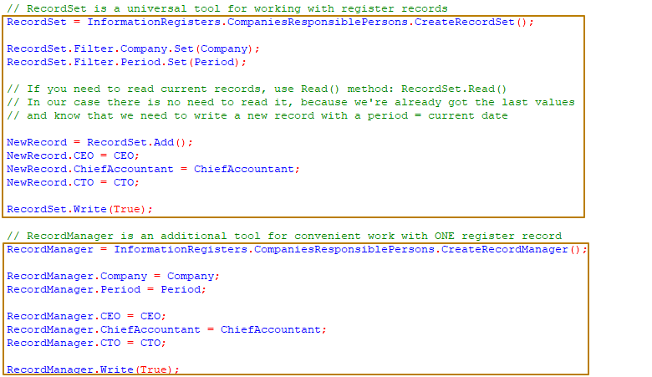
Both tools in the Write() method have a Replace parameter of Boolean type indicating whether records should be overwritten if records with one or more sets of dimensions already exist. In our case, we need to replace the old values, because responsible persons can be changed on the same day for which there is already a record in the register.
In our case, we work from the form with only one register record, so I will use RecordManager.
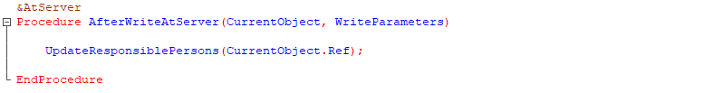
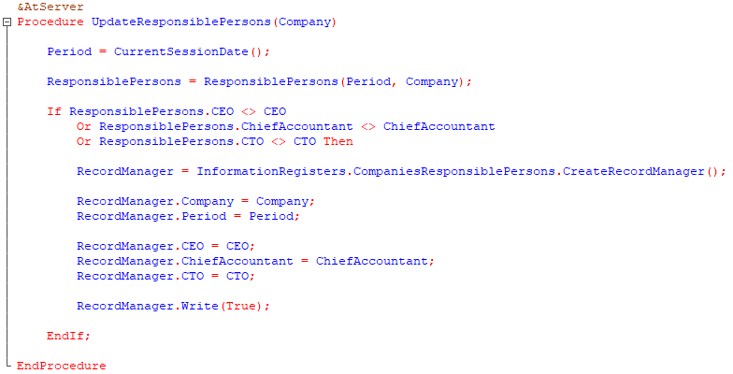
In order to delete one or more records, you can also use the RecordManager and RecordSet tools. RecordManager allows you to delete one record, RecordSet - any number of records using filters by dimensions values and period (for periodical registers).
To delete records using RecordSet, you can use either deleting one record at a time - the Delete() method, or deleting all records by selection - the Write(True) method with forced overwriting:
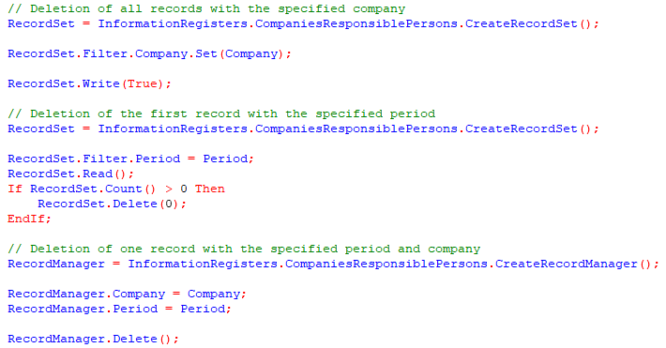
This is how you can work with records of an independent information register.
Working with the information register subordinate to recorder is no different from working with the accumulation register, so there is no point in describing it.

Quick navigation to register records from related objects
Sometimes it is necessary to provide a user with the ability to quickly move from an object to register records in the creation of which this object takes part, because it is convenient for a user. These can be either subordinate or independent registers.
For example, the SalesInvoice document makes movements to the GoodsInWarehouses and Sales registers. In order for the user to be able to view records of a specific document in any of these registers, the developer can configure the visibility of such a transition in the form of the SalesInvoice document. I open the form, go to the Command interface tab, expand the “Go to” branch
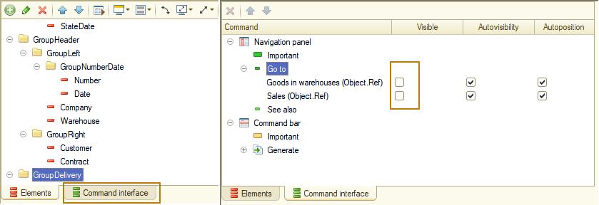
and turn on the flag in the Visible column.
In enterprise mode it looks like this:
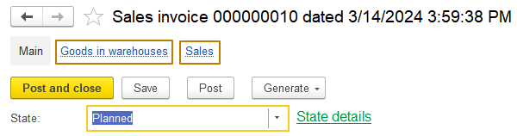
When you go to the tab with register records, a filter is applied to the list by recorder equal to the current document
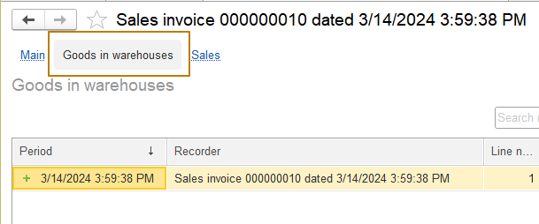
In order for an independent register to be included in the "Go to" branch, additional steps must be taken. Because an independent register does not have a recorder, register entries can be subordinated to objects that are register dimensions. First of all, you need to decide in which dimension objects you want to display a quick transition to register records.
After this, the "Master" property of a dimension should be enabled:
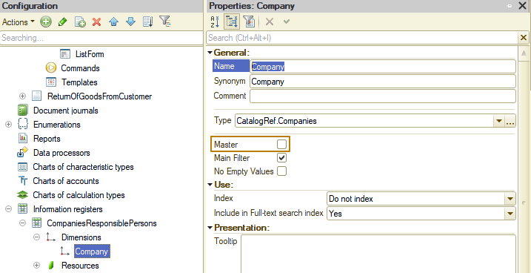
This property indicates that the register record is subordinate to an object, a reference to which is stored in the dimension; if such an object is deleted from the database, the platform will automatically start the process of deleting register records subordinate to the deleted object.
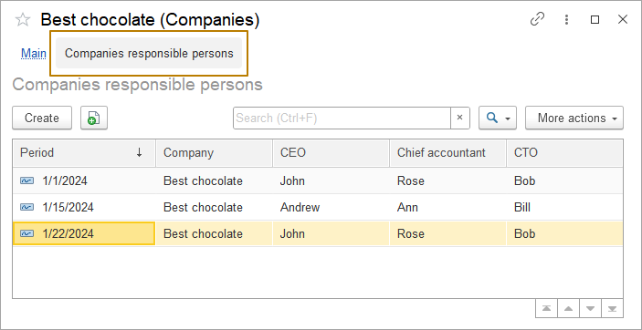
Transactions
Often, when writing an object to a database, it is necessary to write related objects in such a way that if writing at least one object fails, changes to all others within the chain of events are canceled. The 1C platform supports this possibility by providing a transaction mechanism.
A transaction is an indivisible sequence of data manipulations that brings the database from one integral state to a new one. All operations performed within the transaction are either committed (transaction commit) or canceled (transaction rollback).
Transactions can be explicit or implicit:
Implicit - transactions that the platform begins and completes when performing any actions related to the modification of information stored in the database. A developer can build his algorithm in such a way as to interrupt such transactions.
Explicit - transactions that are controlled by developers using code. To do it, they can use the BeginTransaction(), CommitTransaction(), and RollbackTransaction() global context methods.
Let's look at an example when you need to use explicit transactions.
Let's imagine that we download information about customers and their contracts from an external system. In our system, customers are stored in the Counterparties catalog, and contracts are stored in the CounterpartyContracts catalog. A contract without specifying a counterparty does not make sense, therefore the CounterpartyContracts catalog is subordinate to the Counterparties catalog, and the standard attribute Owner is required to be filled out.
So the order of actions during the loading process should be the next one: create a counterparty, fill it out according to the external system data, and write it down. Then create a counterparty contract, fill it out, including a link to the newly created counterparty, then write it down. If an error occurs when recording a counterparty, code execution is interrupted. If an error occurs when recording a contract, it is necessary to cancel the recording of all objects (in our case, the counterparty) so as not to leave only part of the data in the database.
Since we want complete control over the process of changes after the transaction has begun, the code should be placed inside the Try statement of the <Try - Except - EndTry> construction in order to be able to handle errors encountered during execution:
Procedure LoadCounterpartyAndContract(ExternalData)
// no need to begin a transaction inside the Try statement
BeginTransaction();
Try
Counterparty = Catalogs.Counterparties.CreateItem();
FillPropertyValues(Counterparty, ExternalData);
Counterparty.Write();

CounterpartyContract = Catalogs.CounterpartyContracts.CreateItem();
FillPropertyValues(CounterpartyContract, ExternalData);

CounterpartyContract.Owner = Counterparty.Ref;
CounterpartyContract.Write();
// If no errors occurred, commit all changes to the database
CommitTransaction();
Except
// If there was an error, cancel all changes, so they won't be written to the database
RollbackTransaction();

ErrorInformation = DetailErrorDescription(ErrorInfo());

WriteLogEvent(
"Data import",
EventLogLevel.Error,,,
ErrorInformation,
EventLogEntryTransactionMode.Transactional
);

Message(ErrorInformation);
EndTry;

EndProcedure
Any changes to objects after the transaction has started will have no effect on the database until the transaction is committed using the CommitTransaction() procedure, so this code should be the last in the Try block. If any error occurs, the code execution will go to the Except block, where the first step is to cancel the changes made within the transaction, which is why the RollbackTransaction() code is located first in this block. Then you can do all the necessary actions like write the error to the log, report it to the user, and so on.
Let's look at the event diagram of the Document object during its posting. The diagram shows events for posting from the document form using the “Post” or “Post and close” commands (additional events that occur when you click “Post and close” are colored yellow). Events that occur in a transaction that the platform starts and finishes automatically are shaded in gray. The developer can abort and cancel a running transaction by changing the value of the standard parameter Cancel of the event handlers performed in the transaction to True by raising an exception.
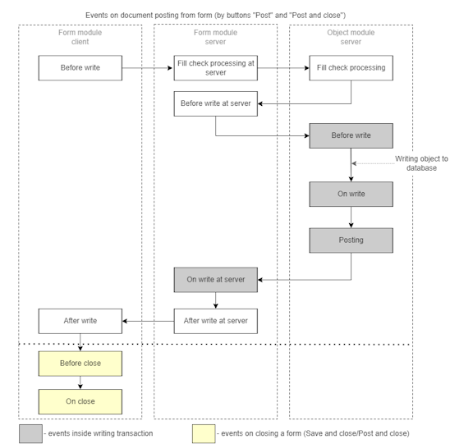
For all other objects stored in the database, which, unlike the document, do not have a posting mechanism, the Posting event is absent, but the remaining events and their order are the same.
Let's return to our task of recording changes in responsible persons from the organization form. I added an algorithm for updating records in the independent information register Companies responsible persons to the AfterWriteAtServer event handler of the Companies catalog item form. The problem is that this event occurs after the write transaction is recorded, which means a situation is possible when the user opened the company form, changed the company data, as well as the data of the responsible persons, clicked the “Write”/“Write and close” button. So there is a change that the catalog object was able to be written to database, after which an error occurred when recording responsible persons, but the sign that the form was modified had already been removed by this point (“Modified” property of a form), the company itself was recorded, which means that the user recorded part of the changes and lost the other part, the user does not have the opportunity to cancel the changes.
In this example, this may look like something insignificant, but in large-scale processes it can play a key role, for example, if when posting a sales document in a certain status, a delivery order should be generated, but in the end the document was posted, but the delivery order was not created and the user cannot create it manually.
Therefore, the algorithm for recording in the register of responsible persons should be transferred to the OnWriteAtServer event, because this event is executed in a transaction and we can abort execution if an error occurs. If responsible persons should be written to the register not only from the form, but also from an object (for example, the Companies catalog would have attributes that affect the register records), then it would be correct to transfer the algorithm to the object event OnWrite (in the object module), because we have already learned that the BeforeWrite event occurs before the object is written to the database.
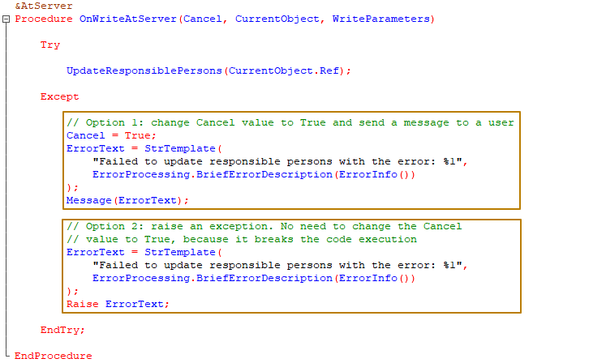
As you can see in the picture, there are 2 ways to cancel a transaction from an event:
1) To change the value of the parameter Cancel to True
2) To raise an exception
The difference between them exists for both the program and the user:
- for the user, the difference is that in the case when we raise an exception, the user sees a window with the error text, an error icon and an OK button, and when we change the value of the Rejection parameter to True, the user sees the error text in the message window at the bottom of the form, and a window with The OK button is displayed only for the Post Processing event, but there is no error text in it, but a text generated by the platform indicating that the document could not be posted.
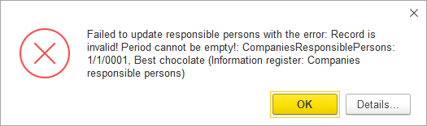
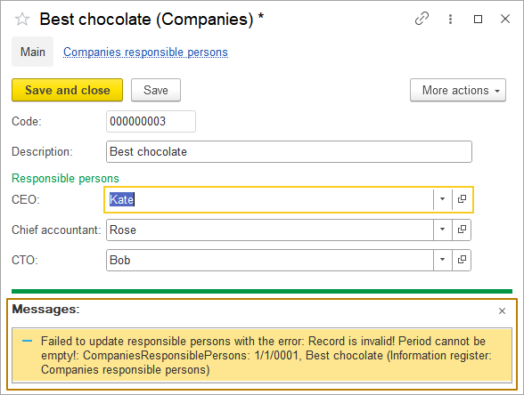
- For a program, the difference is that raising an exception interrupts further execution of the code, but changing the value Failure to True does not. So, in the case when the execution of the code should not be interrupted, as for example in the case of the check that we previously implemented - checking the filling of the Amount column of the Products tabular section of the SalesInvoice document, you should use the first method, otherwise the user will receive a message about only one line with an empty amount, although there may be more such lines.
Errors and exception handling
When working with a program, from time to time implicit exceptional errors arise, that the developer did not call from the code using the Raise operator.
For example, this is an attempt to access a property/attribute of an object that does not have such a property/attribute:
IntegrationSettings = New Structure;
IntegrationSettings.Insert("Name", "James Bond");
IntegrationSettings.Insert("Password", "007");

WebAddress = IntegrationSettings.WebAddress;
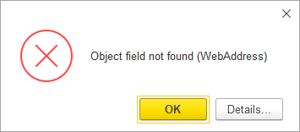
this is an attempt to divide by zero:
Amount = 10;
Quantity = 0;
Price = Amount/Quantity;
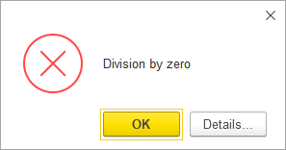

This could also be an error when working with a database object:
NewSalesInvoice = Documents.SalesInvoice.CreateDocument();
NewSalesInvoice.Write(DocumentWriteMode.Posting);
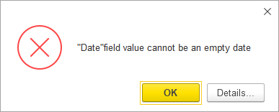
The developer can anticipate and prevent some errors using checks. For example, before dividing one number by another, you should always check that the divisor is not equal to 0.
However, a developer cannot foresee some errors using checks or can, but the number of checks and the code for their implementation can be many times greater than the useful code itself. For example, a developer cannot foresee all the reasons why a document created and posted programmatically may be written with an error. In such cases, code that might cause an error should be executed using the <Try - Exception - EndTry> construct, where the code in the Try block will be executed to catch the exception error. This means that if an exceptional error occurs in this block, it will not break the code execution, but the execution will move to the Except block, where the developer’s task is to properly handle such an error.
In some cases, it is enough to add an event with the information about the error to the Event Log; in other cases, an application should also report the error information to a user. If there is no point in executing the subsequent code, then after completing the initial actions a developer can explicitly raise an exception using the Raise operator (an explicit exception is better than an implicit one, since the developer has the opportunity to perform actions related to the error, as well as modify the error message to make it clearer for the user), as I did when updating register “Companies responsible persons” records:
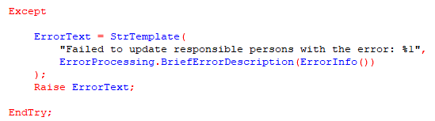
In order to obtain information about an error that has occurred, there are methods of the global context that make sense only in the Except block, such as: ErrorInfo(), ErrorDescription(), as well as the ErrorProcessing global context object, which has the ErrorProcessingManager type and built-in methods for error processing.
Let's look at the example of code for handling an exceptional error:
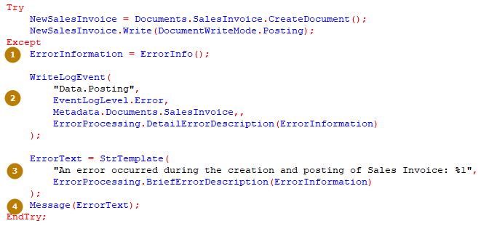
- The global context function ErrorInfo() returns an object of type ErrorInfo containing information about the error that occurred
- The global context procedure WriteEventLog() adds a new record to the Event log with the specified details such as event name, log level, metadata object and others (we'll talk more about the Event log a little later)
- A message for the user is collected into the ErrorText variable using a template, where a description of the error that has occurred is obtained using the BriefErrorDescription method of the ErrorProcessing object
- The resulting error text is sent to the user
Don’t ignore exceptional error handling, this means that you should not write code in the Try block in case an error occurs, and leave the Except block empty without handling the error, since in this way you complicate the detection and correction of errors. Ideally, you should always record information about the exception that occurs in the Event log.
Event log
To perform administrative tasks, it is often required to find out which events occurred at a particular point in time or what actions a particular user performed.
You can find this information in the event log. This log can record various events. Using the event log, the administrator can get the history of user operations.
The event log is not a part of a database and is not saved when exporting/importing an infobase.
1C:Enterprise logs the major actions by users who modify infobases, provide or deny access to data, perform routine operations, sign in, sign out, and so on.
Apart from interactive tools for log operations supported in Designer, log operations can also be defined programmatically. Programmatic work with the log consists mainly of adding log records for logging events using the WriteLogEvent() method.
It is recommended to write events to the log from the built-in language in cases where the administrator needs to provide additional diagnostic information about events that are not recorded by the 1C:Enterprise platform. Such a need may arise both when executing business logic called during interactive work, and in background (scheduled) tasks. For the convenience of analyzing the log, one entry must correspond to one event, and the records themselves must contain a number of mandatory attributes in the context of which the analysis is carried out.
Let's look at the use of the WriteLogEvent() method. The method is available on the server and contains 6 parameters:
WriteLogEvent(
EventName (String),
Level (EventLogLevel),
MetadataObject (Metadata.Documents.SalesInvoice, Metadata.CommonModules.TasksClient...),
Data (Type: Any reference, Number, String, Date, Boolean, Undefined,Null, Type),
Commentary (String),
TransactionMode (EventLogEntryTransactionMode)
);
- Event name. Usually, a configuration contains a large number of event types. For better experience, group event types by their purpose: "Event group name.Event name." For example, you can combine events into the Tasks group:
"Tasks.New task notification"
"Tasks.Pending task notification"
instead of the two event types:
"New task notification"
"Pending task notification"
Event types are used for filtering log records and must not include redundant information such as specific values from an infobase or external systems. Incorrect:
"Cannot cancel posting document <Sales KP00-00002 dated 11/10/2020>"
"Employee John Smith with bank card 3333 is not found in the infobase"
Instead, place metadata in the Metadata parameter and data in the Data parameter of the WriteLogEvent method, and use more generic event types. Correct:
"Document posting.Cannot unpost"
"Employees.Employee not found in the infobase"
- Event level. Critical events, which require greater attention of the administrator, such as business logic errors and application malfunctions, are labeled as "Error." Could-be issues and non-critical errors are registered as "Warning." Successful operation records are labeled as "Information." The lowest possible severity level is "Comment."
- Metadata object. Whenever possible, you should specify the metadata object with which the error occurred. If the error is not tied to a specific metadata object (for example, to the SalesOrder document, the Employees catalog and so on), you can specify the module object in which the error occurred, because this will add flexibility to filter log entries. For example Metadata.CommonModules.IntegrationWith<ServiceName>
- Data. Here a reference to a specific object can be specified, for example, a document that could not be posted, as well as primitive types (String, Number, Date, Boolean), Undefined, Null and values of type Type.
The parameter should be filled in only when there is data that allows you to more accurately set the record filter; in other cases, you can not use this parameter. For example, if as part of an operation there was an attempt to create and write a document, but an error occurred and the object was not written to the database, there is no point in specifying a link, because it will be a reference to a non-existent object.
- Comment. Contains textual unstructured information about the event. If errors occur, this field provides information needed to investigate the cause of the problem. You should not put information about several events at once in a comment. For example, it is incorrect to record one event with a comment like:
[01/01/2020 00:00:01] Beginning of initialization of data exchange according to the "Data exchange upload" setting, setting line number: 1
[01/01/2020 00:00:02] End of data exchange initialization (successful)
[01/01/2020 00:00:03] Start of the data exchange process for the "Data exchange upload" setting, setting line number: 1
[01/01/2020 00:00:04] Start of recording changes to the exchange file
[01/01/2020 00:00:05] Finish writing changes to the exchange file (successfully)
[01/01/2020 00:00:06] End of the data exchange process for the "Data exchange upload" setting, setting line number: 1
[01/01/2020 00:00:07] Done, Uploading data, Processed 1 objects
correctly - is to record as many events as actually happened.
Also, you should not place text data in comments, the size of which is not known in advance and can be as large as possible. For example, the contents of files, web service responses, etc. You should aim for a maximum of 10 KB.
To record information about an exception that occurred in the log, use the following construction:
ErrorProcessing.DetailErrorDescription(ErrorInfo())
- TransactionMode. The value of a service enumeration has two possible options: independent, transactional. If the event occurs within a transaction, the value "Transactional" should be used.
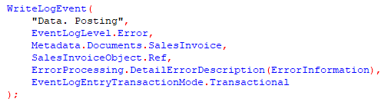
The event log can be opened both in Designer mode and in Enterprise mode. In the designer mode this can be done from the Administration menu (Administration - Event log).
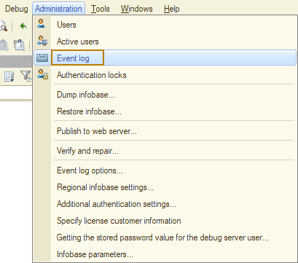
In Enterprise mode it can be done from the “Functions for technician” menu:
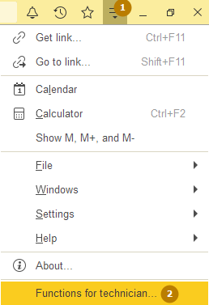
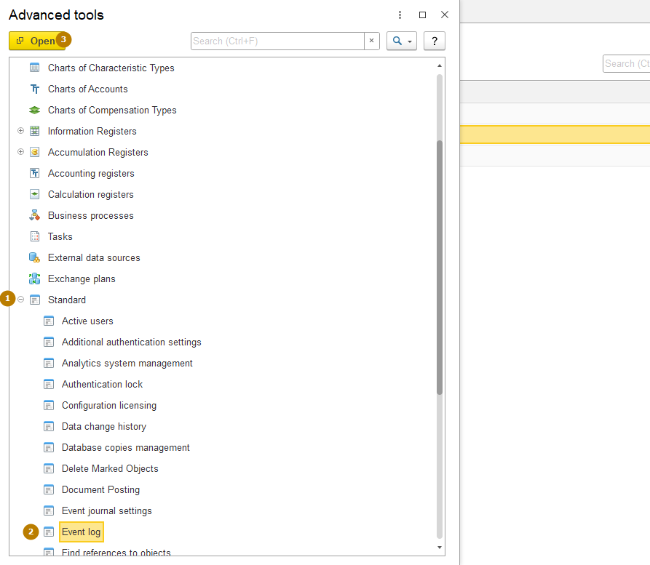
Technician mode is usually disabled in new infobases, so you need to enable it first:
